**FPT ACADEMY INTERNATIONAL**

**FPT – APTECH COMPUTER EDUCATION**



**Centre Name: ACE-HCMC-2-FPT.**

**Address: 590 Cach Mang Thang 8, District 3, Ho Chi Minh City, Viet Nam.**

**CAR DEAL AUCTIONS**

|  |  |  |  |
| --- | --- | --- | --- |
| **Supervisor** | PHAM THI LANH |  |  |
|  |  |  |  |
| **Semester** | 1 |  |  |
|  |  |  |  |
| **Batch No** | T1.2006M1 |  |  |
|  |  |  |  |
| **Group No** | 4 |  |  |
|  |  |  |  |
| **Order** | **Full name** | **Roll No.** | |
|  |  |  |  |
| 1. | LE TRUONG THINH | Student1268780 | |
|  |  |  | |
| 2. | VU DUC THINH | Student1267440 | |
|  |  |  | |

Month 9 Year 2020



This is to certify that

Mr: LE TRUONG THINH

Mr: VU DUC THINH

Has successfully Designed & Developed

CAR DEAL ONLINE AUCTIONS

Submitted by:

Pham Thi Lanh

Date of issue:

October, 5th 2020

Authorized Signature:

**CONTENT**

**ACKNOWLEDGEMENT** 4

**SYNOPSIS** 5

**REVIEW 1** 6

CUSTOMERS REQUIREMENT SPECIFICATIONS (CRS) 7

PROBLEM DEFINITION 8

ARCHITECTURE & DESIGN OF THE SYSTEM 9

SITEMAP 10

WEBSITE LAYOUTS 11

Homepage: 12

Informative pages: 13

TASK SHEET 1 14

**REVIEW 2** 15

WEBSITE INTERFACE 16

Homepage 16

Product page 18

Product-details page 20

Sign-Up page 22

About Us 23

Desclaimers 25

TASK SHEET 2 26

CHECKLIST VALIDATION 27

REFERRENCE 28

# **ACKNOWLEDGEMENT**

I would like to acknowledge all those who have given moral support and helped in making the project a success.

FPT APTECH has created opportunities for student to interact and rub with reality to apply knowledge and skill learned in class into practice . Through this E-project, I have been challenged with IT industry that I am pursuring as well ass learned a lot of new things and accumulated more skills to handle some situations during the work process.

Thiss report booklet has been carefully recorded by my regarding selected information based on my knowledge of an auction online website. Therre by, I will clarify the work that I will do in the future and have more useful knowledge

# **SYNOPSIS**

We were established in 1990, doing one of the pioneers in online bidding field over the years. Our head office is in Vietnam

We are a corporation specializing in bidding for rare antique items. Having been in existence for more than 30 years, it ensures the prestige and safety when you participate in online bidding at our website.

We commit to improve and enhance our product quality, services to achieve the strong brand in consumer’s mind.

The important menu must be stated in the top section of the webpage. Also a decent look out and color combination is expected.

The website is to be developed for the Windows Platform using HTML5, JavaScript and Geolocation. The site should work well in all leading browsers including Chrome, IE, Firefox

# **REVIEW 1**

## **CUSTOMERS REQUIREMENT SPECIFICATIONS (CRS)**

**The Web site is to be created based on the following requirements.**

1) The home page must be designed with beautiful color combination with all the

required links defined properly. Also all the section of the webpage must be in

used to avoid the blank space.

2) Home page should display all available items available for auction as a slide

show.

3) Menu should provide links to various auctions. Categorization of items should

be done viz. Furniture, Paintings etc.

4) On moving to any particular category, it should list various items available for

auction.

5) Clicking on any item should display the details of item along with the base

price of the item.

6) Menu should also provide link to completed auctions displaying the final price

of product/item.

7) About us, Contact Us, Disclaimer must be included.

8) Creating an account facility can also be added.

9) Dummy procedure for placing bid to be added.

10) Sitemap must be added.

11) Navigation of the project must be made smooth.

## **PROBLEM DEFINITION**

After reading the project specifications, the developer states the scope of the project very briefly. This is referred to as the problem definition. Queries of various staff members can be one or all of the following:

1. How many parts can be displayed on Homepage at a time?
2. How to design the hompage and product page looking at smooth?
3. How customers can contact us to join in ?
4. How to make products more valuable?
5. How to impress customers from the start?

**Hardware/ Software Requirements**

**Hardware**

* A minimum computer system that will help you access all the tools in the courses is a Pentium 166 or better
* 64 Megabytes of RAM or better

**Software**

* Notepad/HTML editor
* Dreamweaver
* IE 5.0/ Netscape 6.0

## **ARCHITECTURE & DESIGN OF THE SYSTEM**

**CLIENT**

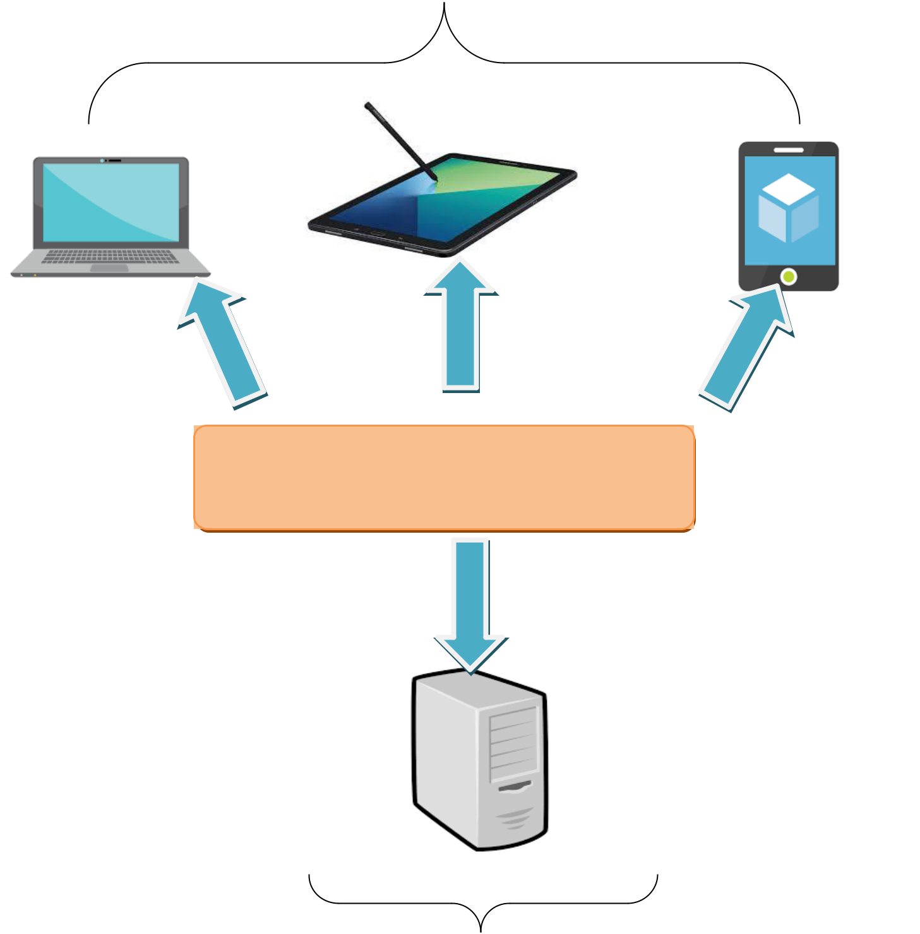

Font End technologies

(HTML5, CSS3, Bootstrap, jQuery)

**SERVER**

## **SITEMAP**

## **WEBSITE LAYOUTS**

**Here are our layouts which will show you how we brainstormed ideas for the hospital’s web pages. Because of being academic website, we tried to build them SIMPLE but USEFUL and INFORMATIVE as much as possible.**

**1. Homepage:**

This layout below describes how we created our Homepage which contain three important parts:

* *Page-header and Navigation bar:*

Navigation bar is included : Logo and other link : About us, Sign in, Our products, Contact us.

* *Content:*

This part is customized belong to the title of the individual websites, especially. The goal of this content is to call to action, making customers feel confident when using the website’s service

* *Footer:*

Simply the time of website establishment.

### Homepage:

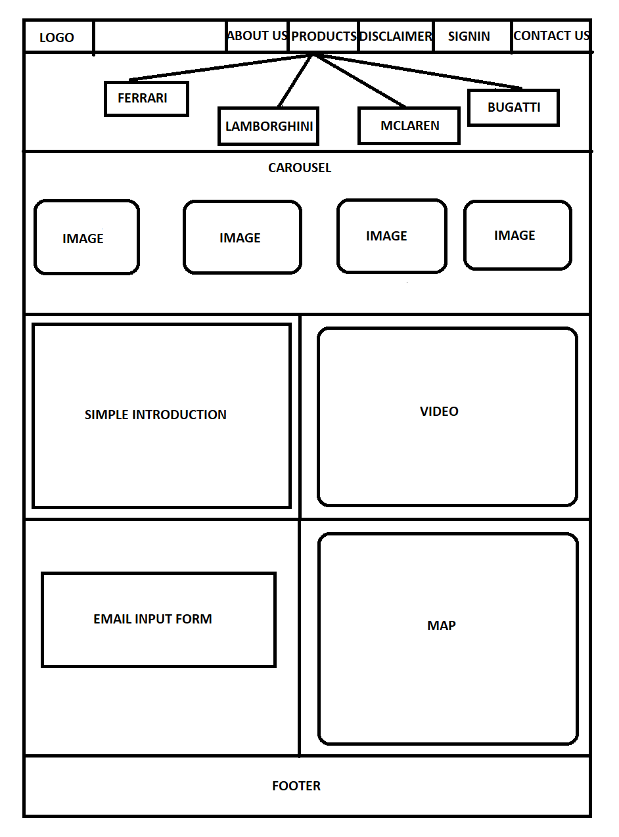

### Informative pages:

## TASK SHEET 1

|  |  |  |  |  |  |  |  |  |
| --- | --- | --- | --- | --- | --- | --- | --- | --- |
| **Project Ref. No.** | | | **Project Title** | **Activity** | **Date of Preparation of Activity Plan** | | | |
|  | |  |  | **Plan** |  |  |  |  |
| **Task** | |  |  | **Actual Start** | **Actual** | **Teammate** | **Status** |
|  |  |  |  | **Prepared** | **Date** | **Days** | **Names** |  |
|  |  |  |  | **by** |  |  |  |  |
|  |  |  |  |  |  |  |  |  |
| Create | layouts | for | CAR DEAL | Nguyen | 5/9/2020 | 2 | Duc Thinh, | Completed |
| website | base | on | AUCTION |  |  |  | Truong Thinh |  |
| group | discussion | |  |  |  |  |  |  |
| ideas |  |  |  |  |  |  |  |  |
|  | | |  |  |  |  |  |  |
| Draw layouts using | | | CAR DEAL | Tai | 7/9/2020 | 2 | Truong Thinh | Completed |
| Paint |  |  | AUCTION |  |  |  |  |  |
|  |  | |  |  |  |  |  |  |
| Write | project | | CAR DEAL | Nguyen | 7/9/2020 | 3 | Duc Thinh | Completed |
| report 1 |  |  | AUCTION |  |  |  |  |  |
|  | | |  |  |  |  |  |  |
| Homepage design | | | CAR DEAL | Nguyen | 10/9/2020 | 7 | Truong Thinh | Completed |
| and | coding | | AUCTION |  |  |  |  |  |
| (include navigation | | |  |  |  |  |  |  |
| bar and footer) | |  |  |  |  |  |  |  |
|  |  |  |  |  |  |  |  |  |

|  |  |
| --- | --- |
| Signature of Faculty | Signature of Leader Team |
|  |  |
|  |  |

# **REVIEW 2**

## **WEBSITE INTERFACE**

### **Homepage**

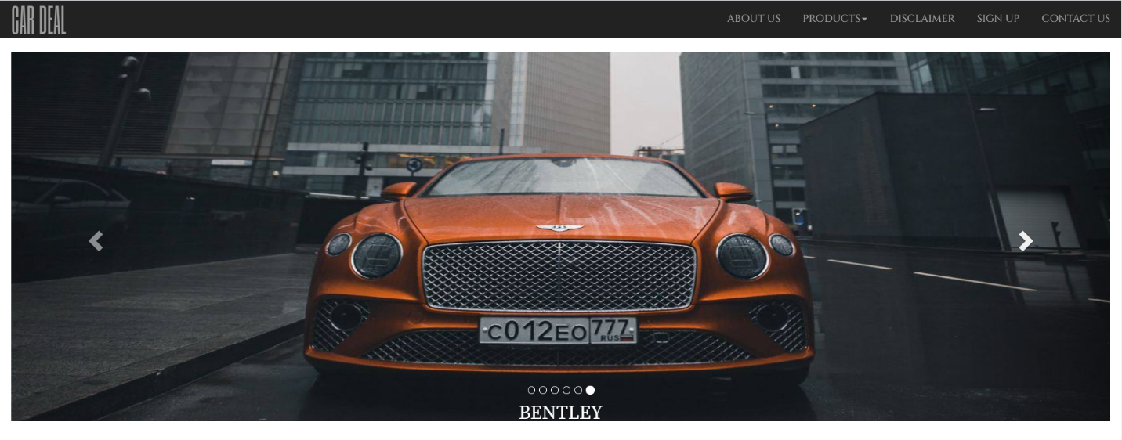

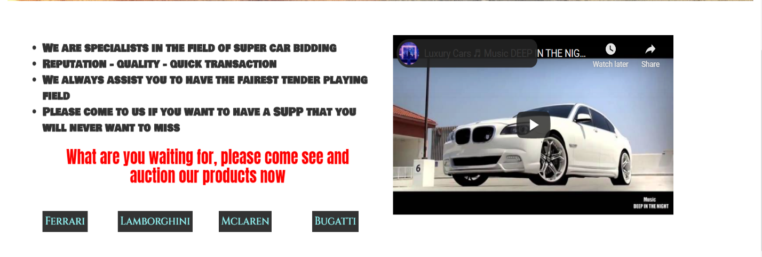

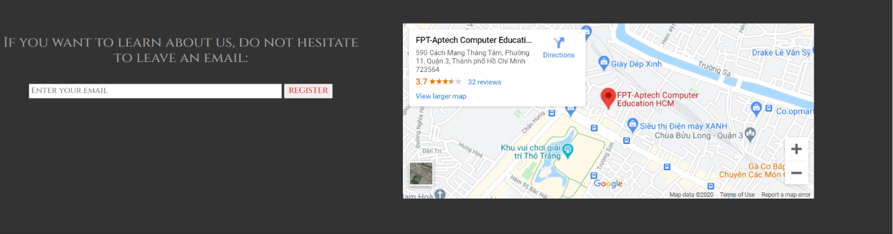



When visitor click to homepage , the video will autorun , They can click navigation-bar which don’t need to scroll up.User can click the image of carousel to link to product of this brand which is showed in carousel.

|  |  |
| --- | --- |
| **Title** | **Description** |
| Contact us | Our store’s address with main contacts  Feedback, Query where people can leave their comments |
| Signin | We can log in or sign up for an account which help patients and visitors management easier |
| Home | Carousel with featured car of our website.  Navigation bar with fixed-position on top  Some text call to action  A video with music which made visitors are more excited  Input email of visitor which help them get the news of our website  Map is included in homepage to make guaranteeing trust  Footer with Sticky Social Bar |
| About us | An introduction to the history of formation and development  Vision and Mission  Subscribe to our Newsletter with email-input  Some information of our team  Sticky Social Bar |
| Product | It has the logo of car brand with great width  The product of this brand will below the logo  The image and name of the car will be show of this page  Visitor can check details of product by pressing the detail button |
| Product-detail | Carousel of 3 image of this product  The table of price and bidding system with Javascript.  Some information of this product and technical specifications of it. |
| Disclaimer | It takes some basic rule of this auction online on our website |

### Product page



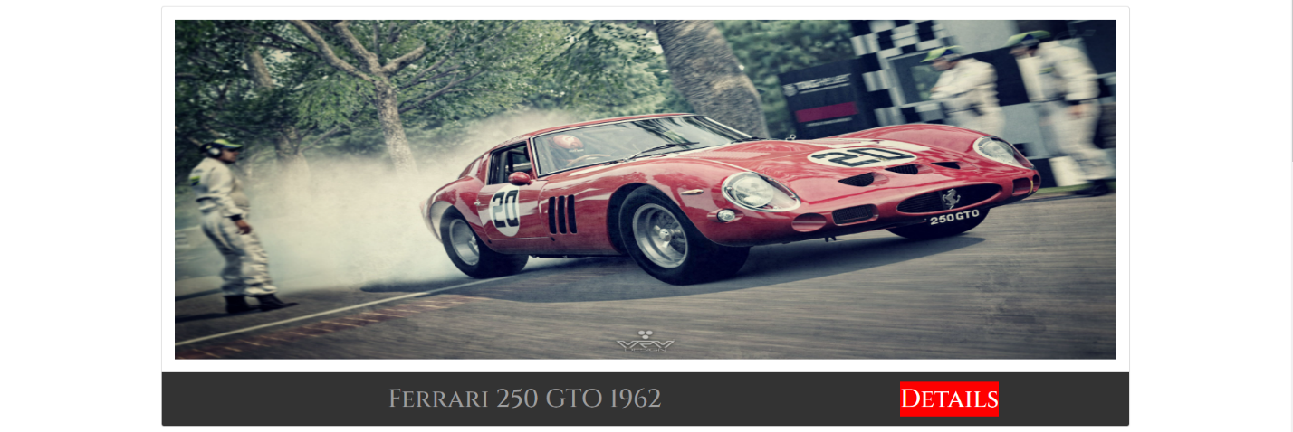

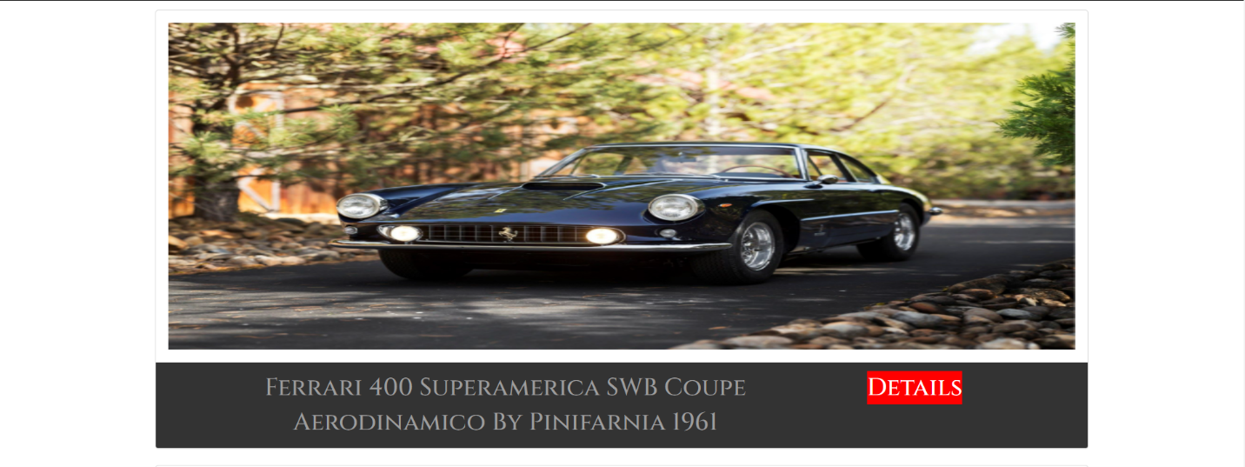

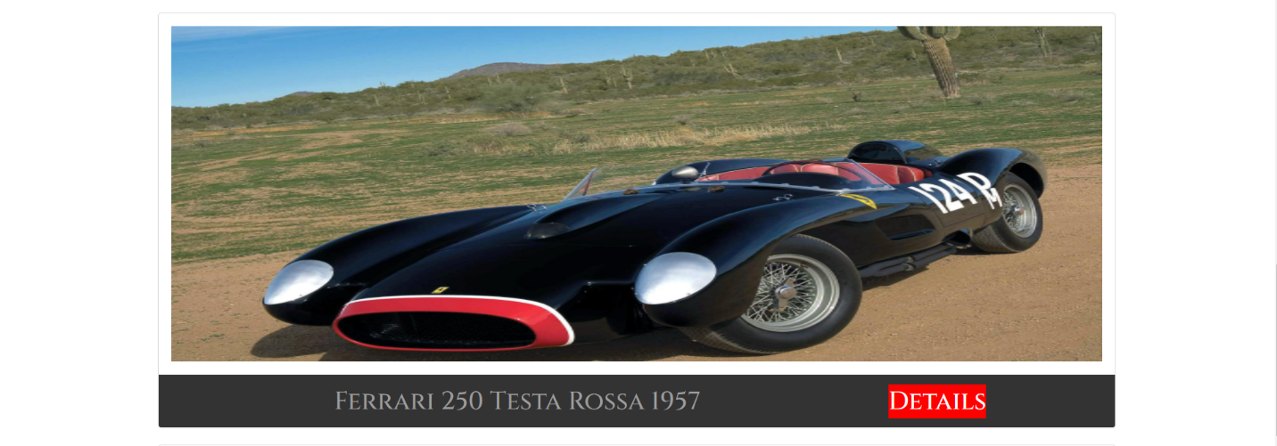

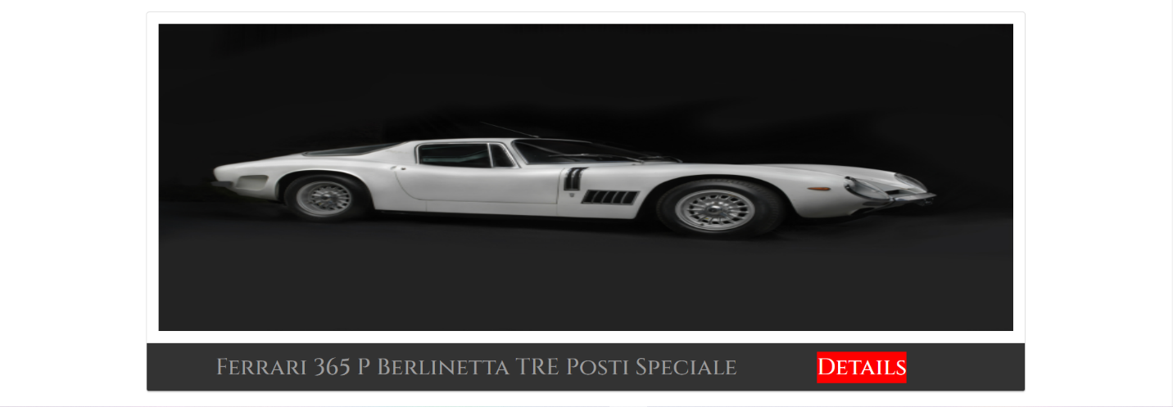



When User click the product on navigation bar or image of carousel , it will link to product page.

### Product-details page

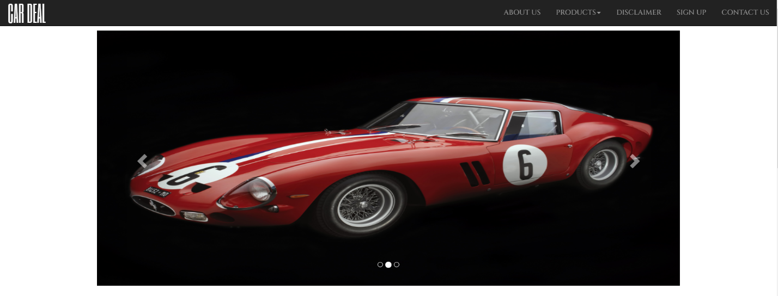

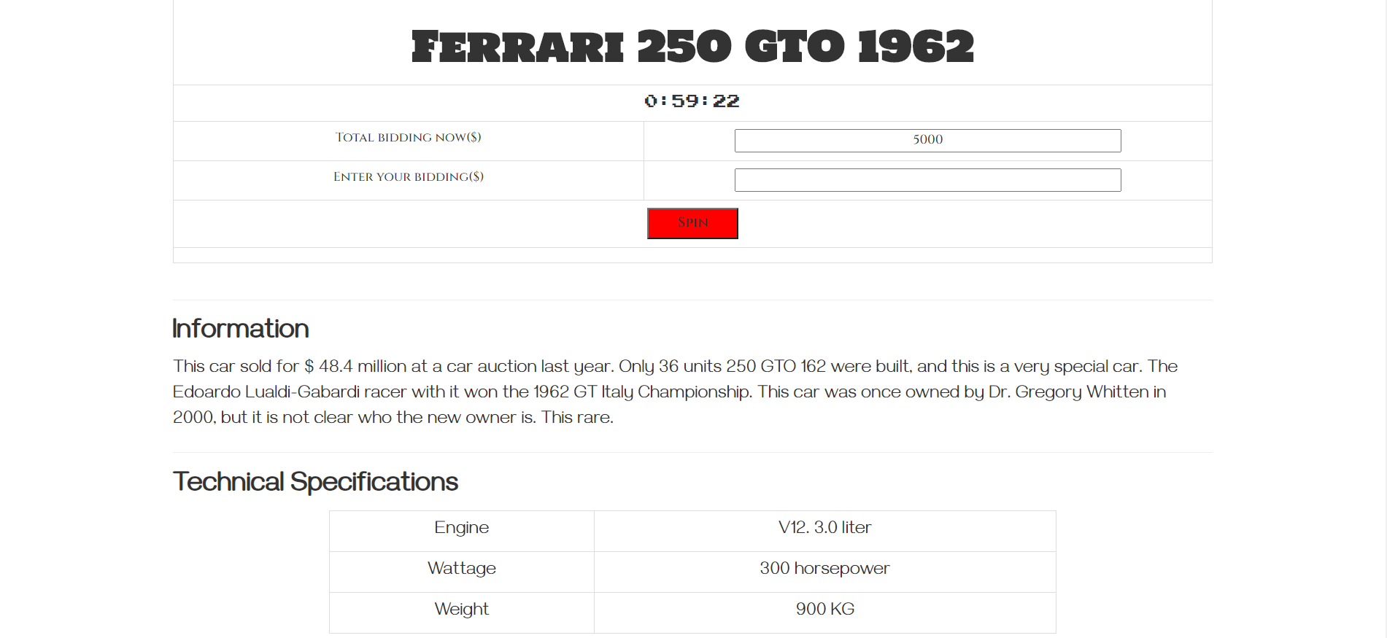



This is our product-details page, you can see the current price of the table, if you want to bid more money , you can write the price and click button spin . Total bidding now will be updated by combining total bidding now before and you bidding.

Morever, We have set time-out system , when time is over, you can’t spin anymore because the button Spin is disable.

### Sign-Up page

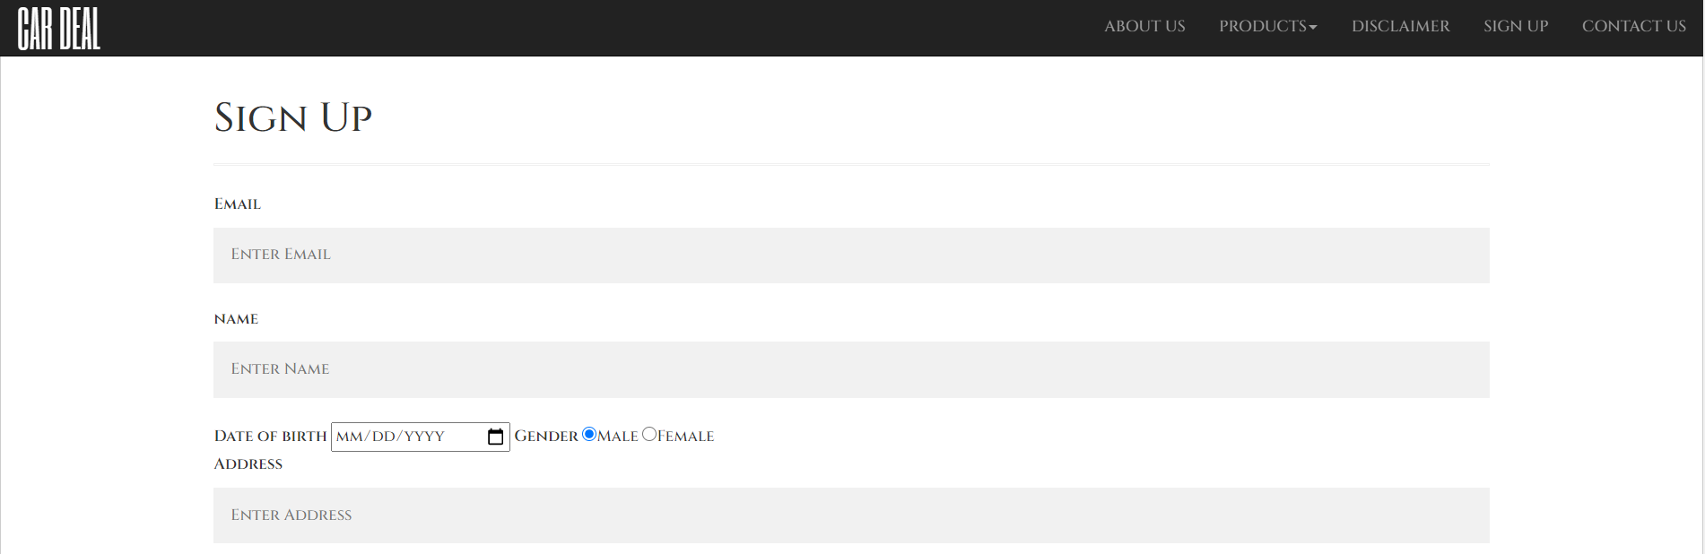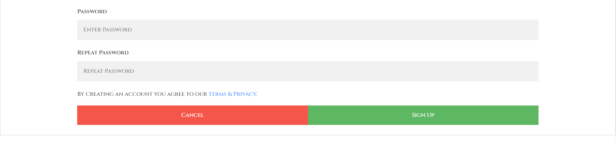



User can click to navigation bar to go to Sign In before bidding product.When you click Button Sign-In which will alert the notification

### About Us

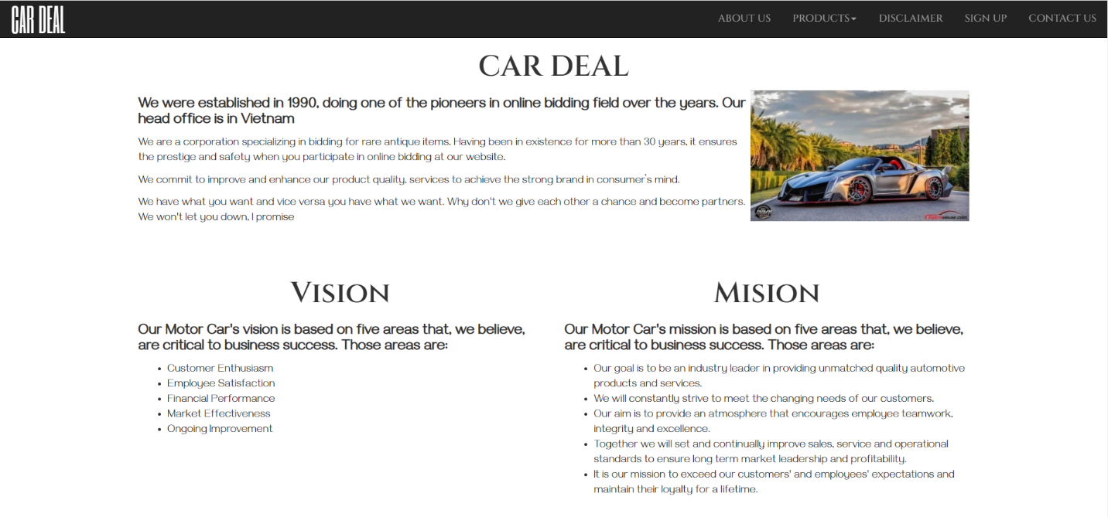







This is all information about this page , the history of development, team work of this page.

### Desclaimers

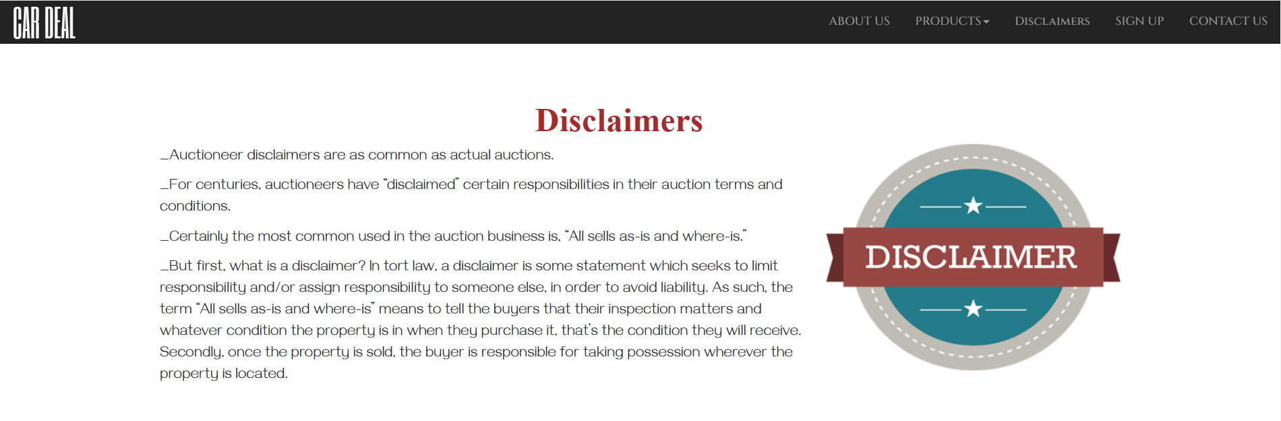

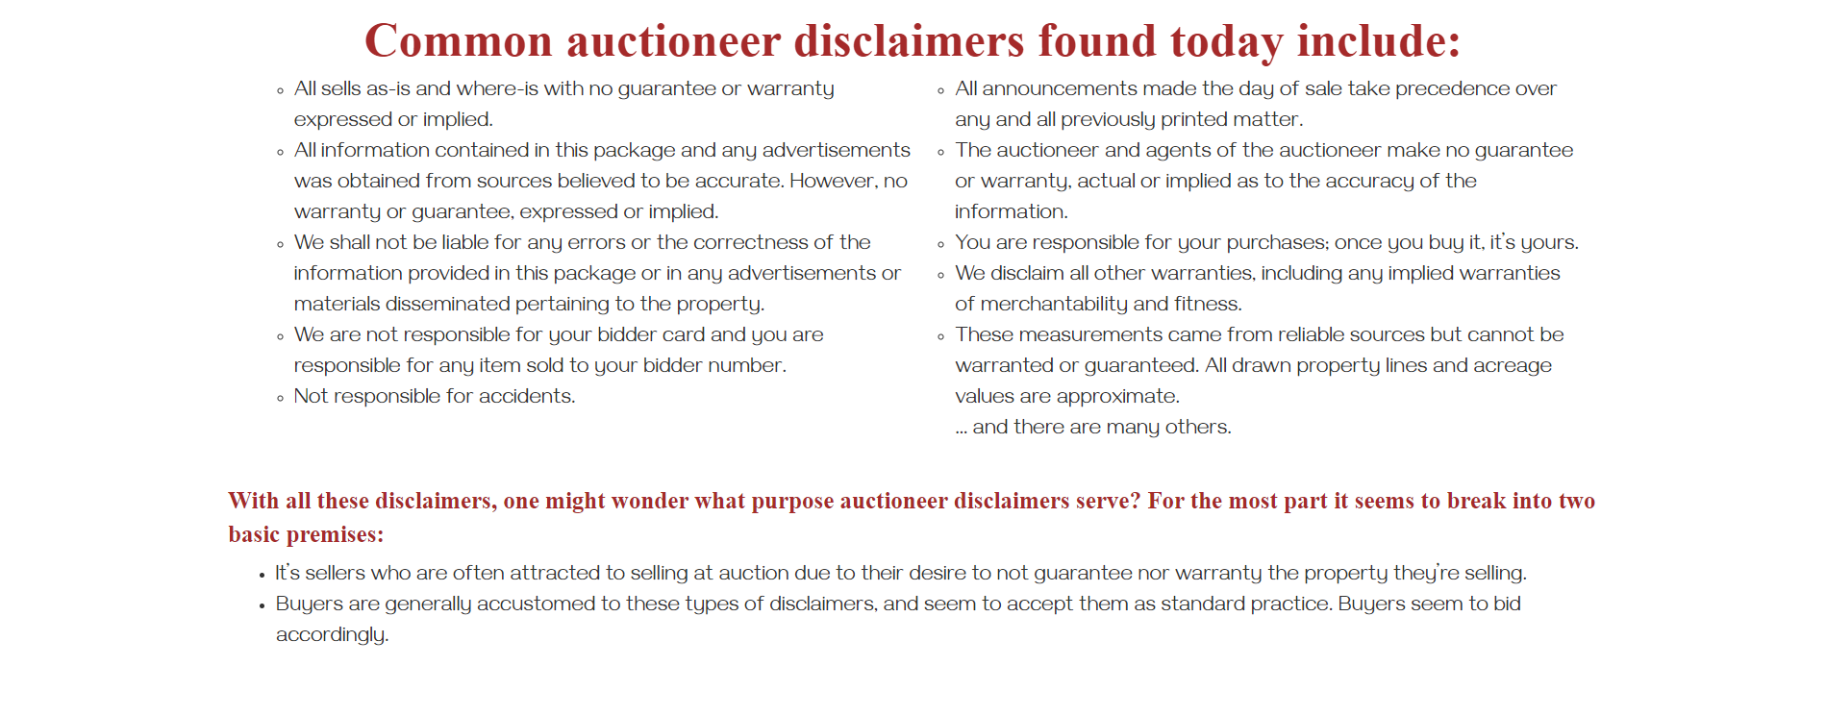



## TASK SHEET 2

|  |  |  |  |  |  |  |  |
| --- | --- | --- | --- | --- | --- | --- | --- |
| **Project Ref.No** | | **Project Title** | **Activity Plan Prepared by** | **Date of Preparation of Activity Plan** | | | |
| **Sr.No** | **Task** | **Actual Start Date** | **Actual days** | **Team mate Names** | **Status** |
| 1. | Design Contact Us page | Car Deal | Thinh | 15/9/2020 | 2 | Duc Thinh | Completed |
| 2. | Design Homepage | Car Deal | Thinh | 16/9/2020 | 1 | Truong Thinh & Duc Thinh | Completed |
| 3. | Desgin Product page | Car Deal | Thinh | 16/9/2020 | 2 | Truong Thinh | Completed |
| 4. | Design product-detail page | Car Deal | Thinh | 19/9/2020 | 1 | Truong Thinh | Completed |
| 5. | Design Login page | Car Deal | Thinh | 20/9/2020 | 1 | Truong Thinh & Duc Thinh | Completed |
| 6. | Desgin About Us page | Car Deal | Thinh | 21/9/2020 | 1 | Duc Thinh | Completed |
| 7 | Create Content of product and overall | Car Deal | Thinh | 17/9/2020 | 7 | Truong Thinh & Duc Thinh | Completed |

## CHECKLIST VALIDATION

|  |  |  |
| --- | --- | --- |
| **Task No.** | **Requirement** | **Validation** |
| 1. | The home page must be designed with beautiful color combination with all the  required links defined properly. Also all the section of the webpage must be in  used to avoid the blank space. | Yes |
| 2. | Home page should display all available items available for auction as a slide  show. | Yes |
| 3. | Menu should provide links to various auctions. Categorization of items should  be done viz. Furniture, Paintings etc. | Yes |
| 4. | On moving to any particular category, it should list various items available for  auction. | Yes |
| 5. | Clicking on any item should display the details of item along with the base  price of the item. | Yes |
| 6. | Menu should also provide link to completed auctions displaying the final price  of product/item. | Yes |
| 7. | About us, Contact Us, Disclaimer must be included. | Yes |
| 8. | Creating an account facility can also be added. | Yes |
| 9. | Dummy procedure for placing bid to be added. | Yes |
| 10. | Sitemap must be added. | Yes |
| 11. | Navigation of the project must be made smooth. | Yes |

## REFERRENCE

1. <https://www.chilindo.com/?feed=everyone>
2. <https://www.w3schools.com/>
3. <https://getbootstrap.com/docs/3.4/>